MyFi Hub — Badlands Stage Canonical Specification
Version: v1.0 (Baseline Lock)
Status: Director-Approved
Scope: Hub Screen – Stage / Viewport / Encounter Experience
Audience: Architect, Executor, Future AI Agents

1. Purpose & Role of the Stage
The Badlands Stage is the visual and experiential core of the MyFi Hub.
It represents the player’s avatar operating in the game world, reacting to real-world financial pressure via encounters, and optionally escalating into direct player-driven combat.
The Stage must:
- Visually ground the player in a living world
- Communicate state, pressure, progress, and consequence at a glance
- Allow seamless movement along an interactivity continuum:
  - Observe → Intervene → Directly Act
- Remain performant and legible on mobile first, without sacrificing richness
The Stage is presentation-only.
It never owns game authority, only renders it.

2. Canonical Principles (Non-Negotiable)
These principles apply to all future iterations.

2.1 Single Stage, Multiple Modes
There is exactly one Stage on the Hub.
It switches between modes; it is never replaced.

2.2 Single Source of Truth
All encounter, battle, vitals, and timing state is owned by hubController (or downstream systems it coordinates).
The Stage:
- Receives immutable snapshots
- May hold UI-only state (tabs, animations, transitions)
- Must never mutate canonical state optimistically

2.3 Continuity Over Screens
Encounters do not “open a new screen.”
They intensify the existing world view.

2.4 Visual Escalation Mirrors Mechanical Escalation
As the player moves closer to direct control, visuals become:
- Larger
- More animated
- More information-dense
- More focused

3. Stage Modes Overview
The Stage has three canonical modes.
All transitions are driven by hubController state.
Mode | Description | Player Agency
World Mode | Avatar patrolling the Badlands | Observational
Encounter (Autobattler) Mode | Encounter resolving automatically | Interventional
Battle (Turn-Based) Mode | Direct ATB combat | Fully active

4. World Mode (Idle / Patrol)

4.1 Purpose
World Mode establishes calm, continuity, and place.
It reassures the player that the system is alive even when they are not acting.

4.2 Visual Composition
- Side-on or angled “world slice” view
- Avatar visible and animated (patrol, idle, travel)
- Environmental motion:
  - Wind
  - Dust
  - Clouds
  - Ambient wildlife or effects
- Background evolves over time:
  - Day → dusk → night
  - Weather shifts
  - Scenery variation
Placeholder: World Mode Visual Reference
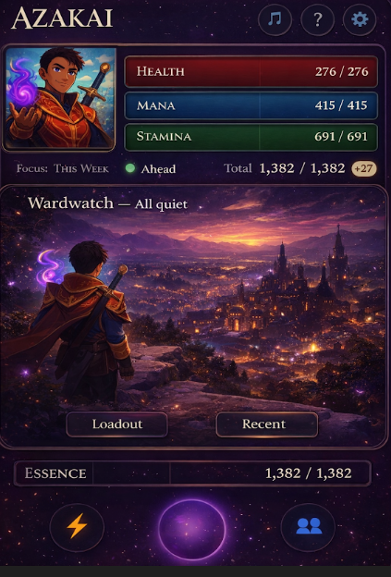

4.3 UI Elements
- Tab Bar (always visible in World & Encounter modes):
  - World (active)
  - Events
  - Loadout
- Minimal vitals indicators:
  - Dots, glows, or subtle meters
  - No numbers
  - Communicates trend, not precision

4.4 Behaviour
- World simulation ticks continuously
- No encounters active
- Player may freely switch tabs
- Stage remains visually dynamic

5. Encounter Mode (Autobattler)

5.1 Purpose
Encounter Mode communicates pressure without panic.
The system is resolving a real-world cost, but the player is not yet forced to act.

5.2 Transition Trigger
- hubController enters active_autobattler
- Stage switches mode automatically

5.3 Visual Changes
- World view persists, but becomes tense:
  - Darkened palette
  - Enemy presence indicators
  - Motion intensifies
- Encounter is visually represented:
  - Enemy silhouettes, chips, or markers
  - Battle-like animation overlays
- Autobattler progress is visible:
  - Countdown ring
  - Progress bar
  - Pressure indicators
Placeholder: Autobattler Encounter Visual Reference
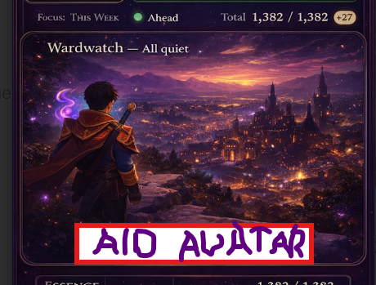

5.4 UI Elements
- “Aid Your Avatar” CTA (primary)
- Optional “View Encounter” affordance
- Mini vitals bars with trend arrows
- Encounter timer (non-blocking)

5.5 Behaviour
- Autobattler resolves in background
- Player may:
  - Ignore (auto-resolve)
  - Switch tabs
  - Enter Battle Mode
- Vitals update in real time

6. Battle Mode (Turn-Based / ATB)

6.1 Purpose
Battle Mode is focused, dramatic, and consequential.
It is where player intent directly shapes outcomes.

6.2 Transition Trigger
- Player selects “Aid Your Avatar”
- hubController enters active_turn_based

6.3 Layout (Portrait Default)
- Top: Battlefield / enemies
- Middle: Combat log (compact, scrollable)
- Bottom: Player HUD
  - Avatar portrait (large)
  - Full vitals bars (Health / Mana / Stamina / Shield)
  - ATB bar
  - Skill buttons
Placeholder: Turn-Based Battle Layout Reference
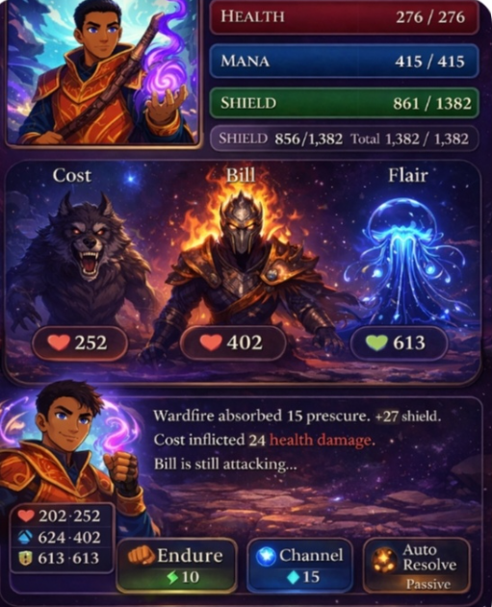

6.4 Landscape Option
- Battle Mode may optionally rotate to landscape
- Landscape prioritises:
  - Enemy clarity
  - Skill readability
- Vitals remain visible at all times

6.5 Interaction Model
- Hold → Release skill confirmation
- Default target auto-selected
- Player has limited time per turn
- Enemy turns progress independently via ATB

6.6 Skills (Baseline)
- Attack (Stamina)
- Arcane Bolt (Mana)
- Additional slots rendered dynamically
- No hard-coded skill count

6.7 Exit Behaviour
- Player may exit back to Encounter Mode
- Encounter continues if unresolved
- Victory returns to World Mode after summary

7. Vitals & Feedback Contract

7.1 Canonical Rules
- Vitals are owned by hubController
- Stage and PlayerHeader are read-only
- No optimistic local mutation

7.2 Display by Mode
Mode | Vitals Representation
World | Minimal dots / glow
Encounter | Compact bars + trend icons
Battle | Full bars + numeric feedback

7.3 Emotional Feedback
- Health loss = dramatic, heavy feedback
- Mana/Stamina spend = mitigative, controlled feedback
- Essence accrual = subtle, rewarding feedback

8. Tabs: Events & Loadout

8.1 Events Tab
- Recent encounters
- Outcome summaries
- Time since occurrence
- No deep interaction in v1

8.2 Loadout Tab
- Equipped tactics / skills
- Toggle auto-resolve preference
- No direct editing during battle
Tabs are disabled in Battle Mode.

9. Mobile & Accessibility Constraints
- Must function at ≤ 360px width
- No overlapping critical controls
- Text legible without zoom
- Touch targets ≥ 44px
- Animations degrade gracefully

10. Non-Goals (Explicitly Out of Scope)
- Multi-enemy tactical layouts
- Persistent battle state across reloads
- Skill trees
- Narrative branching
- Multiplayer

11. Anti-Drift Rules
Any future change that:
- Introduces a second viewport
- Mutates vitals locally
- Adds timing logic to the Stage
- Bypasses hubController authority
Requires a new Director session.

12. Summary
The Badlands Stage is:
- One place
- Three modes
- Zero authority
- High emotional bandwidth
- Mobile-first but not mobile-limited
This document defines what must be true.
The Work Orders define how it is built.

